Snowflake E2E Billing Accelerator - Comprehensive Technical Documentation
1. Overview
This document outlines the design, architecture, and user guide for the Snowflake Cost Management Accelerator, a comprehensive billing and financial analytics platform built using Streamlit. The application provides enterprise-grade cost monitoring, spending analysis, consumption tracking, and financial forecasting capabilities across Snowflake organizations and accounts.
Purpose: To streamline Snowflake cost management and financial visibility through an intuitive web interface, enabling finance teams, database administrators, and data engineers to monitor consumption, optimize resource allocation, forecast spending, and manage budgets effectively across the enterpri
Intended Results: Enhanced financial control through data-driven cost insights, improved resource allocation decisions, identification of cost anomalies and spending inefficiencies, early warning systems for budget overruns, and standardized cost management practices across the organization.
2. Objectives
Financial Monitoring: Real-time tracking of credit consumption, cost trends, spending patterns, and budget forecasting across all Snowflake resources at organization and account levels
Cost Breakdown Analysis: Comprehensive cost attribution by compute, cloud services, storage, and other billable services with detailed trend analysis
Anomaly Detection: Statistical identification of unusual spending patterns using control chart methodology (mean ± 2σ) for proactive cost management
Consumption Insights: Service-level consumption analysis including warehouse utilization, user-level cost estimation, and hourly cost patterns
Storage Cost Integration: Storage usage tracking with configurable pricing models to calculate database storage costs and assess storage-to-compute ratios
User & Warehouse Analytics: Attribution of costs to specific users and warehouses with query count correlation for detailed resource utilization analysis
Spend Forecasting: 7-day spend projections using linear regression for budget planning and early anomaly detection
Resource Optimization: Identification of high-cost resources, underutilized warehouses, and optimization recommendations for cost reduction
Operational Efficiency: Reduce manual cost reporting through automated dashboards and intelligent analytics Decision Support: Provide actionable financial insights for infrastructure planning, cost optimization, and budget allocation
3. Requirements
Core Financial Features
Organization Overview: Organization-wide financial snapshot including total spend, daily averages, peak consumption, and account-level distribution
Account Overview: Account-level cost analysis with compute, cloud services, and storage cost breakdown with detailed trend visualization
Daily & Cumulative Spend Trends: Historical spend analysis with dual-axis visualization showing daily costs and running totals
Cost Distribution Analysis: Pie charts and stacked visualizations showing cost attribution across service types and resources
Top Accounts/Warehouses: Ranking analysis of highest-cost resources for prioritization of optimization efforts
User-Level Cost Estimation: Attribution of credits to specific users based on query count proportions for departmental cost allocation
Hourly Cost Patterns: Time-of-day cost analysis for identifying peak usage windows and scheduling optimization opportunities
Advanced Analytics Features
Cost Anomaly Detection: Statistical control charts identifying spending outliers beyond mean ± 2 standard deviations with anomaly frequency and impact metrics
7-Day Spend Forecast: Linear regression-based forecasting for budget planning and early detection of spending trends
Service Type Breakdown: Classification of costs by Snowflake service types (compute, cloud services, etc.) with trend analysis
Storage Cost Analysis: Configurable storage pricing with average storage tracking, storage cost calculation, and compute-to-storage ratio analysis
Warehouse Cost Distribution: Stacked bar charts showing compute vs. cloud services costs per warehouse with query count overlay
Multi-Dimensional Filtering: Date range selection for custom period analysis (Last 7 days, 30 days, custom ranges)
Corporate Styling: Enterprise-grade visual design with corporate color scheme and professional UI components
4. System Architecture
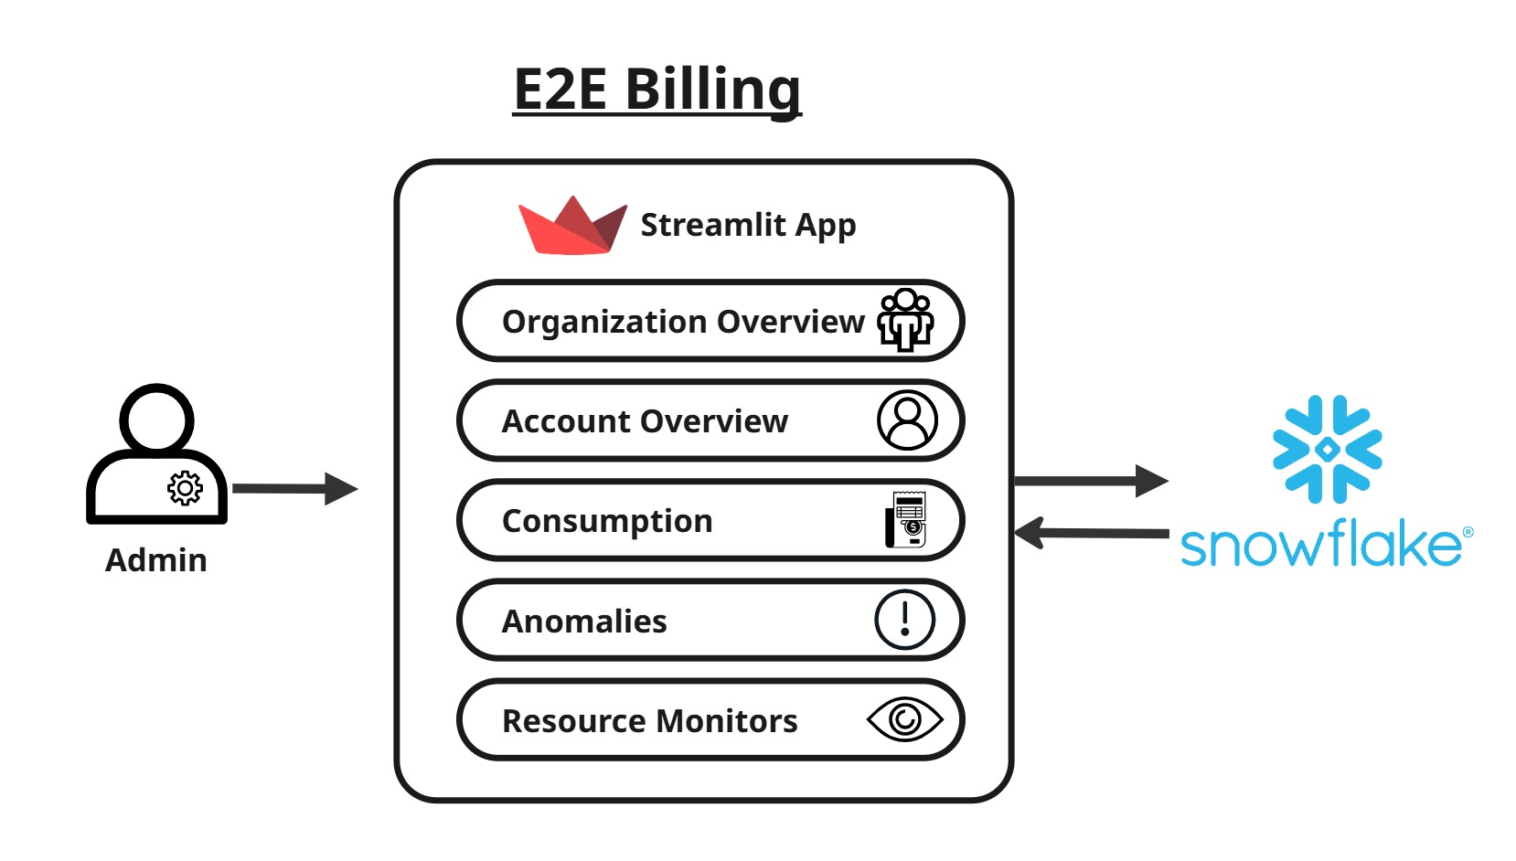
The Snowflake Cost Management Accelerator follows a three-tier architecture with clear separation between presentation, business logic, and data layers.
Presentation Layer (Streamlit Frontend):
- Web Interface: Streamlit-based responsive single-page application with sidebar navigation and tabbed content sections
- Session Management: Stateful user sessions with date range, pricing configuration, and filter persistence
- Component Library: Reusable metric cards, charts, and data tables with corporate styling
- Error Handling: User-friendly error messages with fallback data for robustness
- Responsive Design: Adaptive layout for desktop and mobile viewing
Business Logic Layer:
- Query Builders: Dynamic SQL query generation based on user filters and date ranges
- Financial Calculations: Credit-to-USD conversion, cost attribution, storage calculations
- Statistical Processing: Anomaly detection using z-score methodology, linear regression forecasting
- Data Transformations: Pandas-based data manipulation, aggregation, and formatting
- Session State: Centralized management of date ranges, pricing parameters, and user preferences
Data Layer:
- Snowflake Connectors: Native Snowflake Python connector for secure database connectivity
- Connection Pooling: Cached session management for efficient resource utilization
- System Views: Access to ACCOUNT_USAGE and ORGANIZATION_USAGE schemas for billing data
- Query Optimization: Server-side aggregation to minimize data transfer
- Caching Strategy: Time-based cache for frequently accessed data
5. Application Structure & Components
Session State Initialization
The application maintains persistent state for:
Date Range: Start date (default: 30 days ago) and end date (today)
Pricing Configuration: Credit price per unit and storage price per TB/month These values persist across user interactions and page reruns
Tab Structure
Tab 1: Organization Overview
- Aggregated financial metrics across all accounts
- Daily spend trends with cumulative visualization
- Top 10 accounts by spending
- Account count and peak daily spend tracking
Tab 2: Account Overview
- Account-level cost summary (compute, cloud services, total)
- Query count tracking
- Storage cost integration with compute-to-storage ratio
- Daily cost trends and hourly patterns
- 7-day spend forecast
- Top warehouses by cost with query count overlay
- Top users by estimated cost
Tab 3: Consumption Analysis
- Service type cost breakdown (compute, cloud services, etc.)
- Service cost trends over time
- Top 20 warehouse consumption analysis
- Stacked area charts for service distribution
Tab 4: Cost Anomalies
- Anomaly detection using statistical control charts (mean ± 2σ)
- Anomaly summary metrics (count, impact, frequency)
- Control chart visualization with bounds, mean, and outliers
- Identification of unusual spending days
Tab 5: Resource Monitors
- Display of active Snowflake resource monitors
- Resource monitor creation interface
- Quota and trigger configuration
6. Data Sources & Schemas
Primary Data Sources
Organization-Level Views:
- SNOWFLAKE.ORGANIZATION_USAGE.USAGE_IN_CURRENCY_DAILY
- Daily spend in USD by account
- Used for organization overview and cross-account analysis
- Grain: One row per account per day
- Key columns: usage_date, account_name, usage_in_currency
Account-Level Views:
- SNOWFLAKE.ACCOUNT_USAGE.WAREHOUSE_METERING_HISTORY
- Credit consumption by warehouse and time
- Used for warehouse cost analysis and hourly patterns
- Grain: One row per warehouse per hour
- Key columns: warehouse_name, start_time, credits_used_compute, credits_used_cloud_services
- SNOWFLAKE.ACCOUNT_USAGE.METERING_HISTORY
- Service-level credit consumption
- Used for service breakdown and daily trends
- Grain: Varies by service type
- Key columns: service_type, start_time, credits_used
- SNOWFLAKE.ACCOUNT_USAGE.QUERY_HISTORY
- Query execution details
- Used for user-level cost attribution and query counting
- Grain: One row per query
- Key columns: query_id, user_name, warehouse_name, start_time, total_elapsed_time
- SNOWFLAKE.ACCOUNT_USAGE.STORAGE_USAGE
- Storage capacity metrics
- Used for storage cost analysis
- Grain: One row per date
- Key columns: usage_date, storage_bytes
Administrative Views
- SNOWFLAKE.ACCOUNT_USAGE.RESOURCE_MONITORS
- Credit limit configurations and status
- Used for resource monitor display
7. Feature Specifications
7.1 Organization Overview
Metrics Displayed:
- Total Spend (USD): Sum of all daily spend across all accounts
- Average Daily Spend: Mean daily spend across the selected period
- Peak Daily Spend: Maximum single-day spend
- Total Accounts: Count of distinct accounts
Visualizations:
- Daily Spend Bar Chart: Daily spend in USD with colour gradient
- Cumulative Spend Line: Running total of spend over time (secondary axis)
- Top 10 Accounts Bar Chart: Horizontal bar chart of highest-cost accounts
- Top 5 Distribution Pie Chart: Account cost distribution for top 5 accounts
Data Queries:
- Aggregates from ORGANIZATION_USAGE.USAGE_IN_CURRENCY_DAILY
- Filters by date range selected in sidebar
- Groups by account_name for top accounts analysis
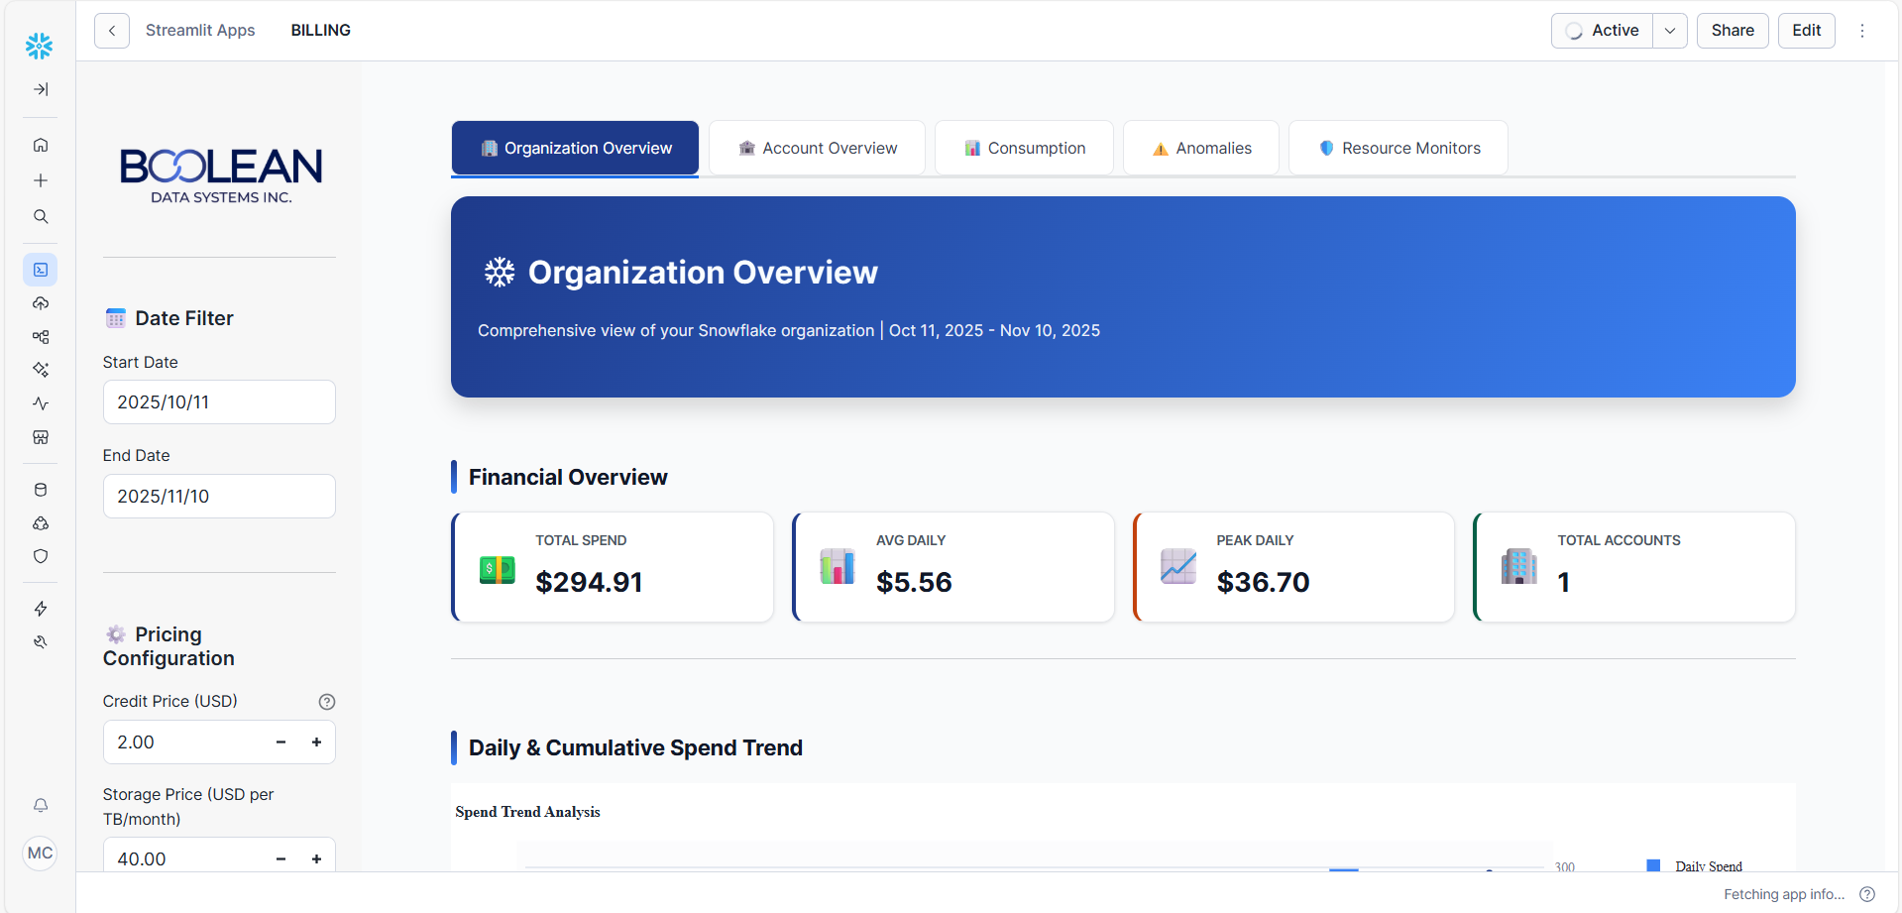
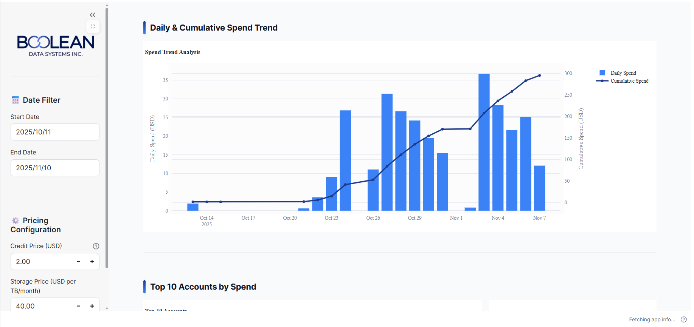
7.2 Account Overview
Cost Summary Section:
- Total Cost: Sum of compute + cloud services costs
- Compute Cost: Total compute credits × credit price
- Cloud Services Cost: Total cloud service credits × credit price
- Total Queries: Count of distinct query IDs in period
Storage Integration:
- Average Storage (TB): Average daily storage across period
- Storage Cost: Average storage × configurable price per TB
- Compute-to-Storage Ratio: Ratio of compute cost to storage cost for efficiency assessment
Cost Breakdown Charts:
- Pie Chart: Distribution of compute vs. cloud services costs
- Area Chart: Daily cost trend showing spend over time
Top Users Analysis:
- User Cost Attribution: Estimated user cost based on query proportion
- Query Count: Number of queries executed by user
- Horizontal Bar Chart: Top 10 users ranked by estimated cost
Hourly Cost Patterns:
- Line Chart: Average cost by hour of day
- Identifies peak usage windows for scheduling optimization
7-Day Spend Forecast:
- Combines historical data with linear regression
- Displays both actual costs (solid line) and forecast (dotted line)
- Enables budget planning and trend detection
Warehouse Cost Analysis:
- Stacked Bar Chart: Compute vs. Cloud services cost per warehouse
- Line Overlay: Query count per warehouse (secondary axis)
- Tables: Detailed warehouse data with all metrics
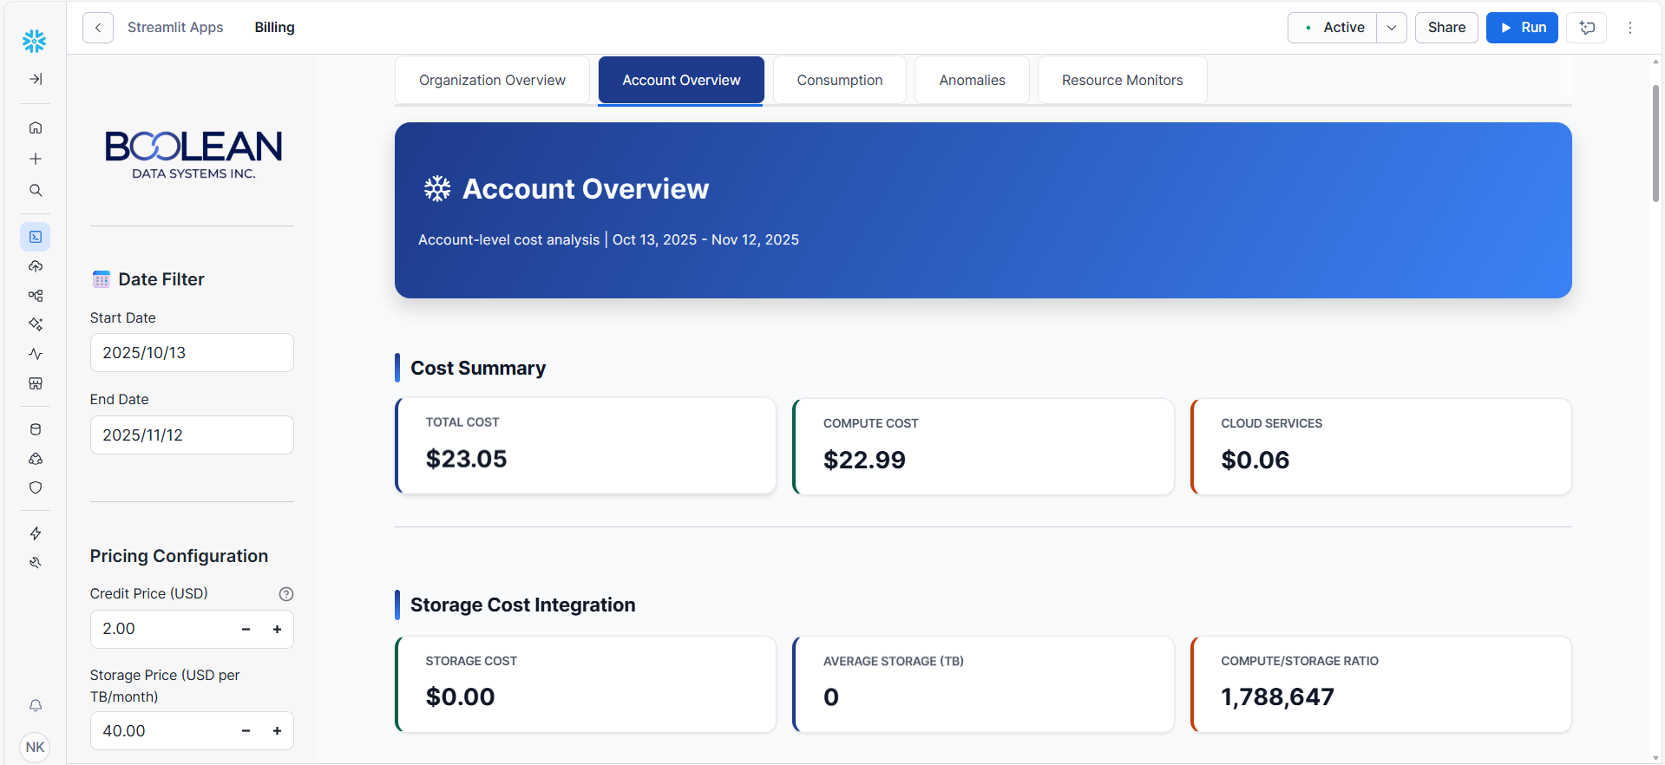
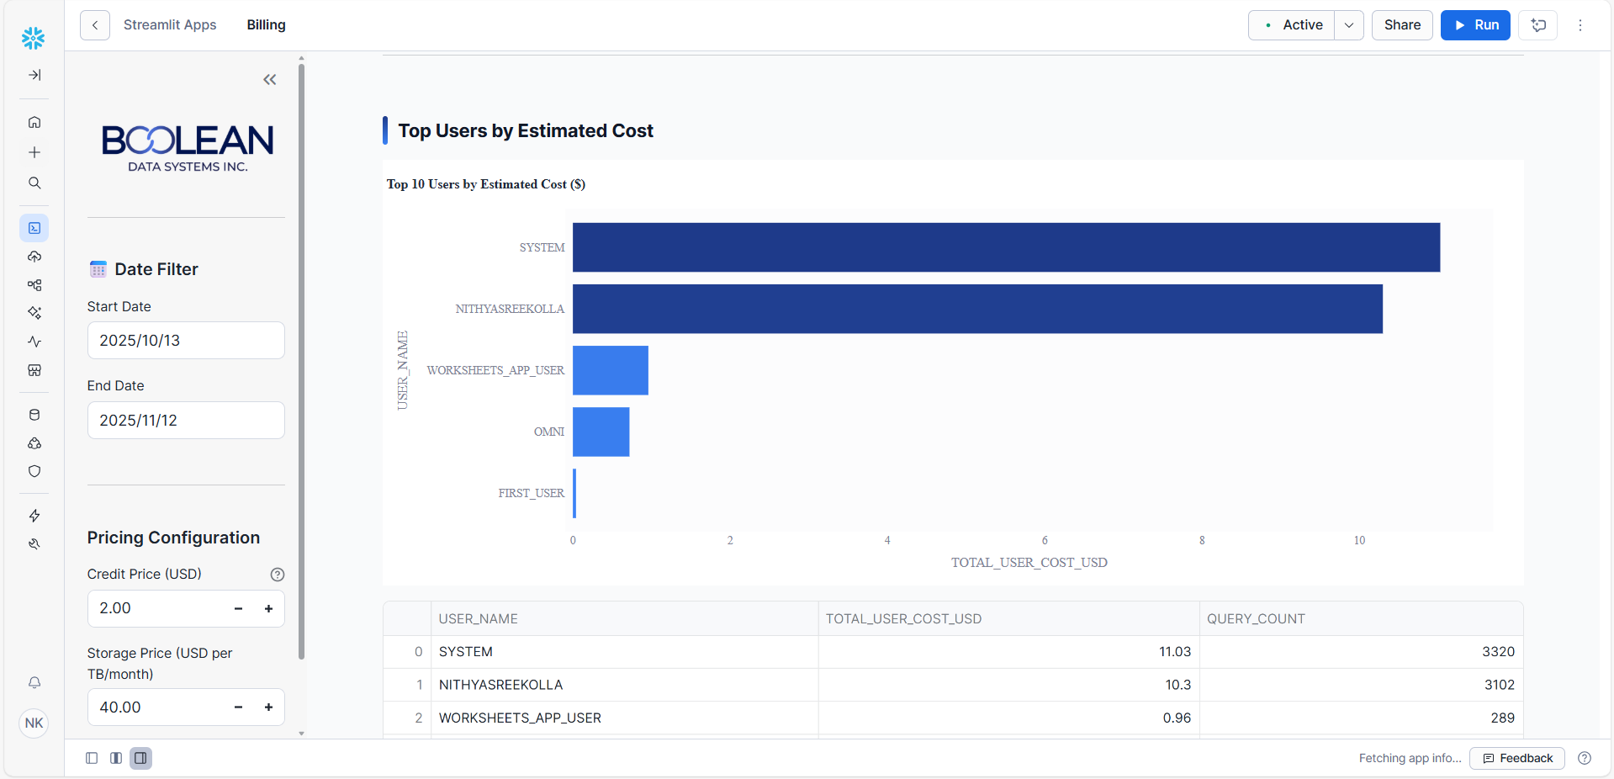
7.3 Consumption Tab
Service Breakdown:
- Metric Cards: Cost by service type with icons and formatting
- Percentage Display: Percentage of total cost per service
- Stacked Area Chart: Service cost trends over time
Warehouse Consumption:
- Top 20 Warehouses: Sorted by total cost
- Horizontal Bar Chart: Consumption costs per warehouse
- Color Intensity: Cost magnitude indicated by color gradient
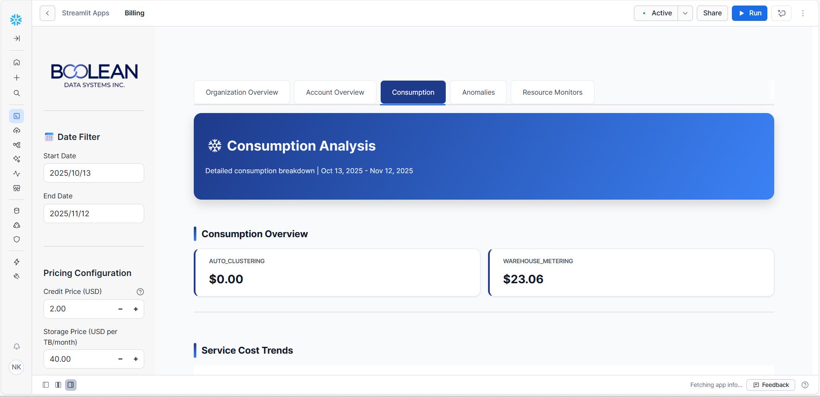
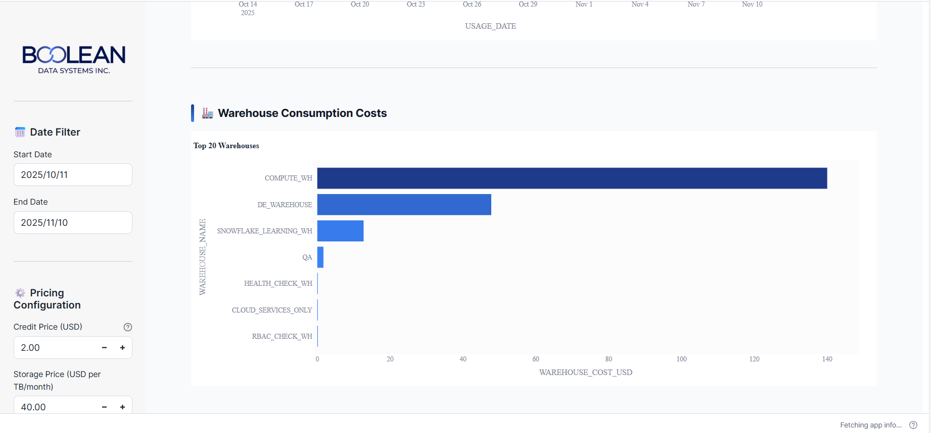
7.4 Anomaly Detection
Anomaly Metrics:
- Anomalies Detected: Count of days beyond ± 2σ from mean
- Anomaly Cost Impact: Total spend on anomalous days
- Anomaly Frequency: Percentage of days with anomalies
Control Chart Visualization:
- Upper/Lower Bounds: Shaded region showing normal range (mean ± 2σ)
- Mean Line: Dashed horizontal line at mean cost
- Actual Costs: Line chart of daily costs
- Anomaly Markers: Diamond markers highlighting anomalous days
- Interactive Hover: Detailed cost information on hover
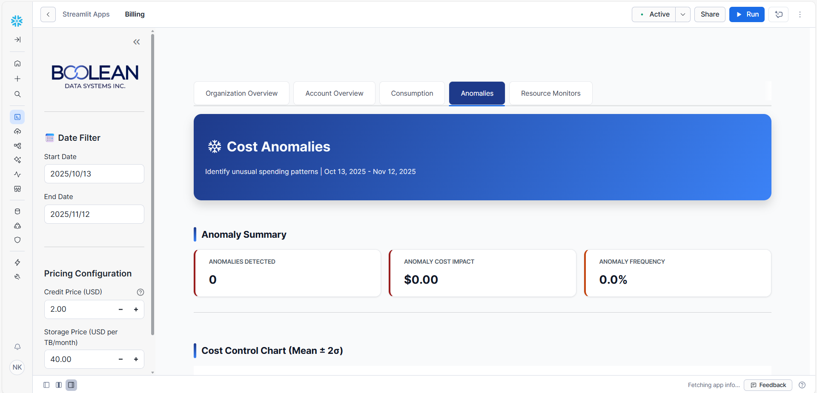
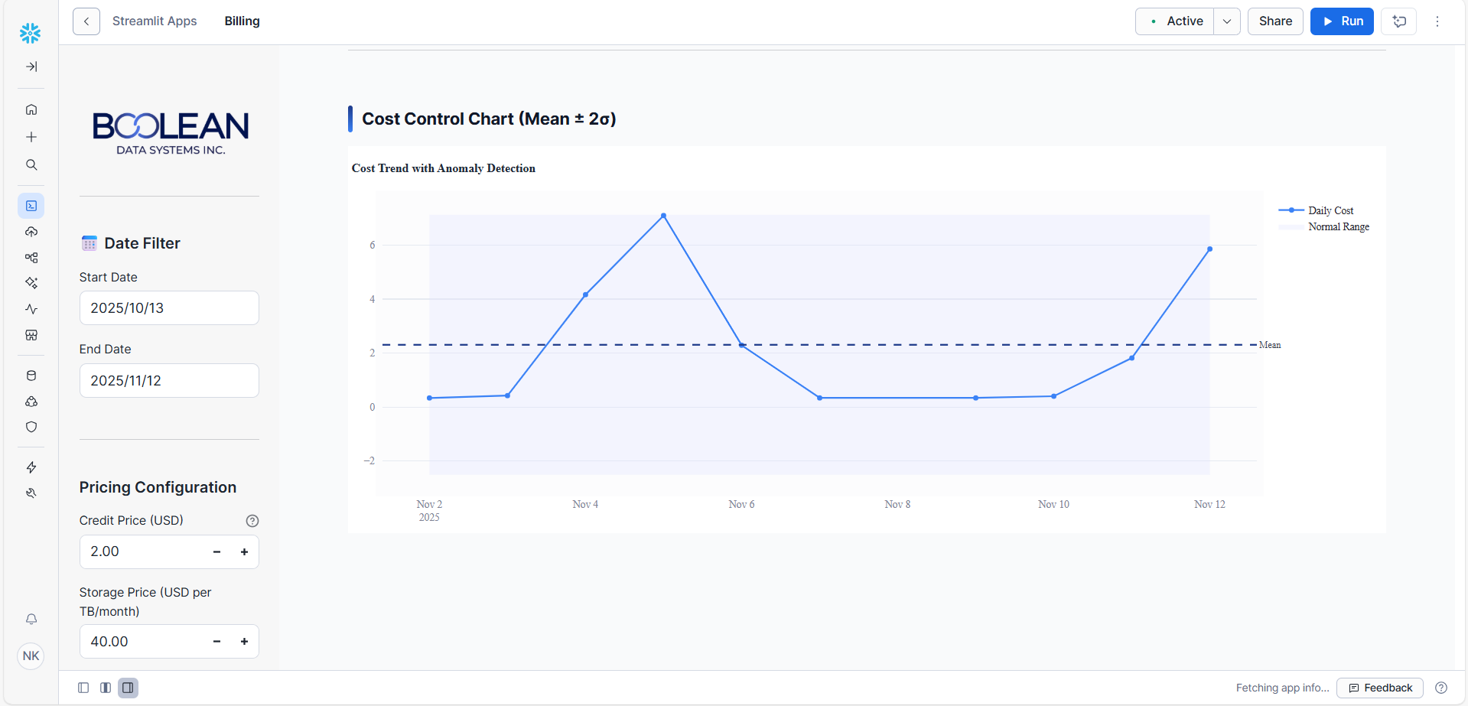
7.5 Resource Monitors
Monitor Display:
- Table: Active resource monitors with configuration
- Columns: Monitor name, credit quota, frequency, trigger thresholds
Monitor Creation:
- Form Input: Monitor name, credit quota, frequency selection
- Threshold Controls: Sliders for notify and suspend percentages
- Submission: Button to create new monitor
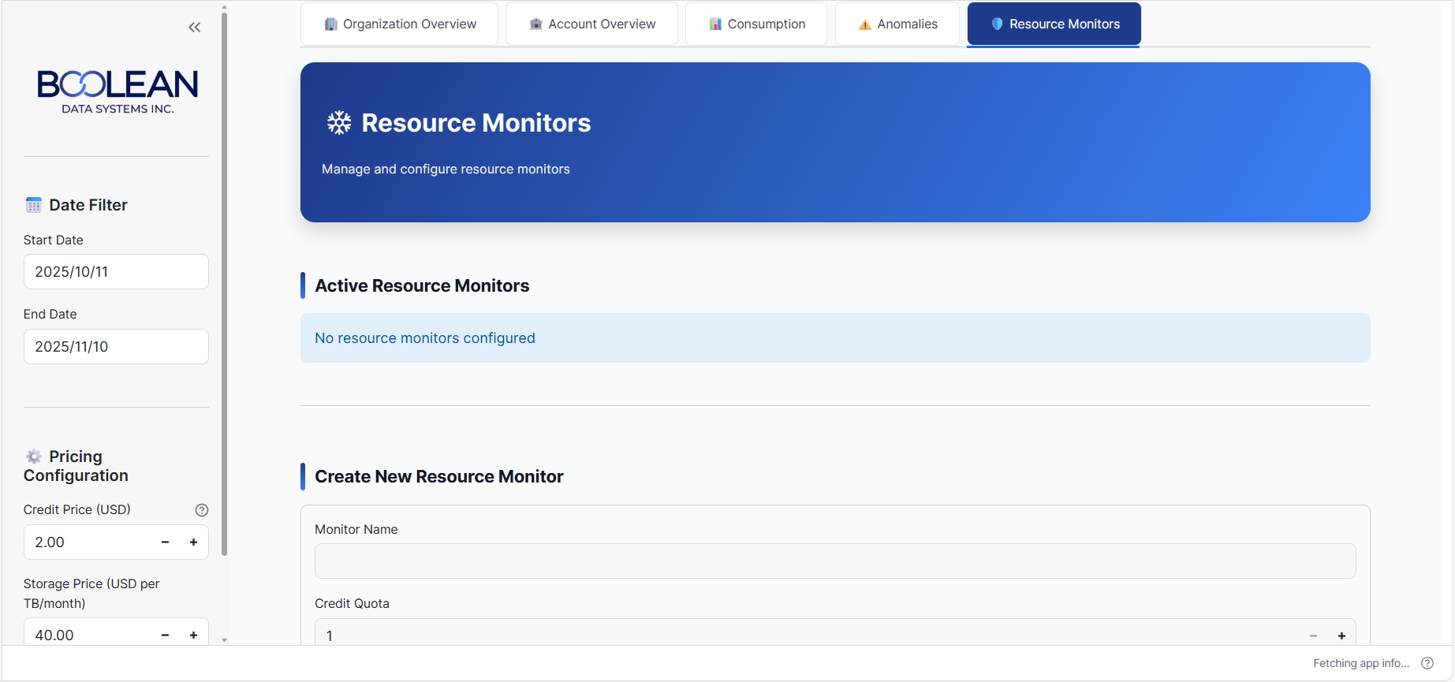
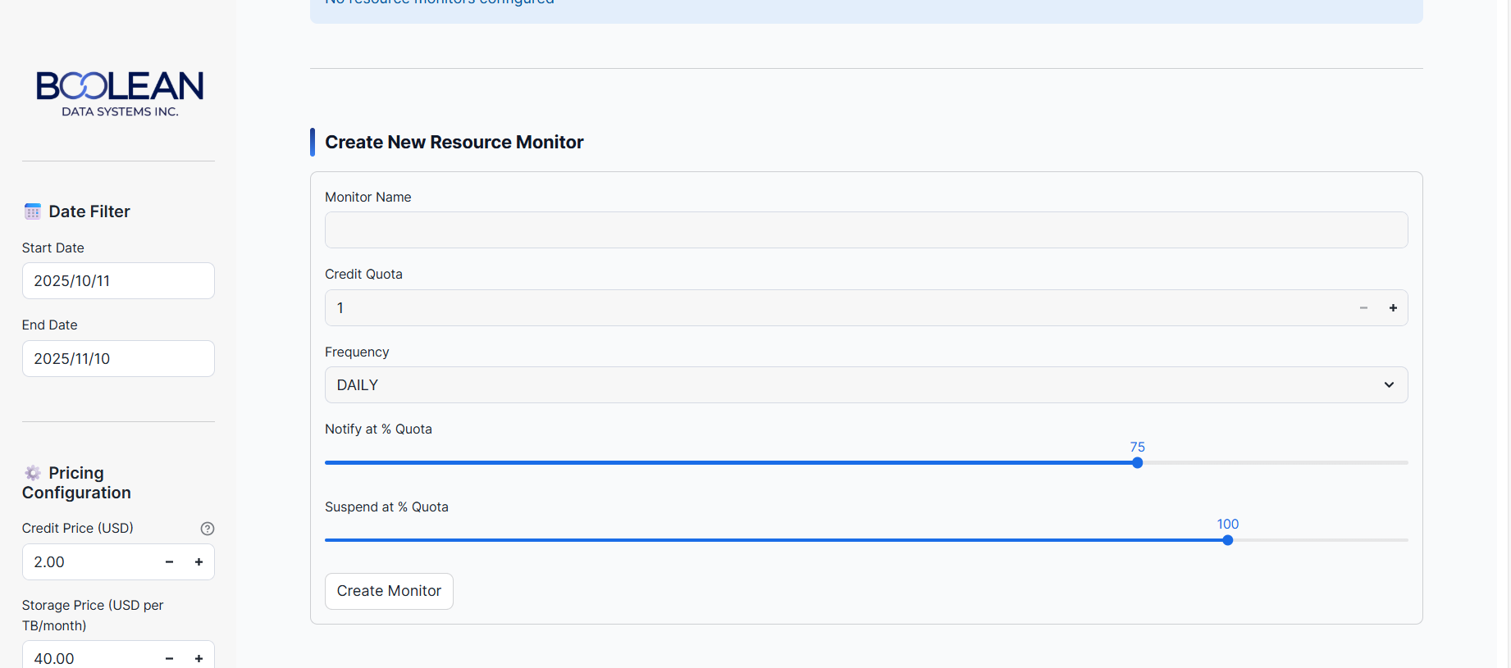
8. Technology Stack
Core Technologies
Frontend Framework: Streamlit 1.28+ for rapid web application development and interactive dashboard creation
Visualization Libraries:
- Plotly Express: High-level API for quick chart creation
- Plotly Graph Objects: Low-level control for complex visualizations
- Plotly Subplots: Multi-axis charts (secondary y-axis support)
Database Connectivity: Snowflake Python Connector and Snowpark for secure database connections
Data Processing: Pandas for data manipulation, aggregation, and transformation Numeric Processing: NumPy for array operations and mathematical calculations Statistical Analysis: SciPy (stats module) for linear regression and statistical testing Styling: Custom CSS with corporate design system implementation
Date/Time Handling: Python datetime module for date range calculations
Development & Deployment
Development Environment:
- Python 3.9+
- Streamlit CLI for local development
- Environment files for configuration
Deployment Options:
- Streamlit Cloud: Managed deployment with git integration
- Cloud Platforms: AWS EC2, Google Cloud Run, Azure App Service
- On-Premise: Docker container for enterprise deployments
9. Data Flow & Processing
Query Execution Flow
1. User Interaction: User adjusts date range or configuration in sidebar
2. Session State Update: Streamlit updates session state with new values
3. Query Construction: Application builds SQL queries based on user selections
4. Query Execution: Snowflake connector executes queries and returns results
5. Data Transformation: Pandas processes results (sorting, filtering, aggregation)
6. Calculation: Apply cost formulas (credits to USD conversion, anomaly detection, etc.)
7. Visualization: Plotly creates interactive charts from processed data
8. Rendering: Streamlit renders updated dashboard with new values
10. Security & Privacy
Authentication & Authorization
- Snowflake Authentication: Native Snowflake user authentication integrated with application
- Role-Based Access: Query results filtered by user's Snowflake role permissions
- Session Management: Secure session handling through Snowflake connector
- Credentials: Stored in .streamlit/secrets.toml with environment isolation
Data Security
- Connection Encryption: TLS 1.2+ for all Snowflake connections
- Read-Only Operations: Application uses SELECT-only queries on system views
- SQL Injection Prevention: Parameterized queries via session.sql()
- Data Minimization: Only cost and usage columns accessed, no business data
Privacy Controls
- Query Isolation: Each user sees only data accessible by their Snowflake role
- Audit Trail: All queries logged in Snowflake QUERY_HISTORY
- Access Logging: Snowflake session tracks user identity and query execution
- Data Retention: System views auto-cleaned per Snowflake retention policie
11. Best Practices for Users
Cost Optimization
- Monitor warehouses consuming >15% of total credits for optimization opportunities
- Review storage costs monthly for unused objects and archival candidates
- Set warehouse auto-suspend to 5 minutes or less to eliminate idle costs
- Identify query spillage using QUERY_HISTORY for optimization priority
- Track compute-to-storage ratio to ensure balanced resource investment
- Review user cost attribution monthly to identify departmental anomalies
Financial Management
- Establish credit budgets per department or cost center
- Set anomaly thresholds for alert sensitivity (consider adjusting ±2σ default)
- Review forecasts weekly to catch spending trends early
- Archive cold data to external stages for storage cost reduction
- Compare actual vs. forecast monthly to refine spending models
Operational Excellence
- Use consistent date ranges for period-over-period comparison
- Document cost drivers for organizational knowledge
- Share dashboards with stakeholders for cost awareness
- Correlate cost spikes with business events (deployments, increased usage)
- Create cost allocation models for chargeback purposes
12. Conclusion
The Snowflake Cost Management Accelerator provides a comprehensive platform for financial visibility and cost optimization in Snowflake environments. By combining real-time data aggregation, advanced analytics, and an intuitive user interface, it enables organizations to make data-driven decisions about resource allocation and cost management.
The modular architecture and flexible configuration support various deployment scenarios and customization requirements. Security is built-in through Snowflake's native authentication and role-based access controls, while performance optimization ensures responsive operation at scale.

